**VOTING ELIGIBILITY**

1.Begin

2.Read age

3.if age is greater than or equal to 18

      print as "eligible for voting"

4.Else

      print as "not eligible for voting"

5.End procedure

**ADMISSION POSSIBILITY**

1.Begin

2.Read marks

3.if marks is greater than or equal to 70

      print as " join your dream college"

4.Else

      print as "not join your dream college"

5.End procedure

**SUM AND AVERAGE OF THREE NUMBERS**

1.Begin

2.Read the variables a,b,c

3.calculate sum equals to addition of a and b

4.Calculate average equals to the total sum is divisible by three

5.Display sum and average

6.End procedure

**VOTING ELIGIBILITY FLOWCHART**

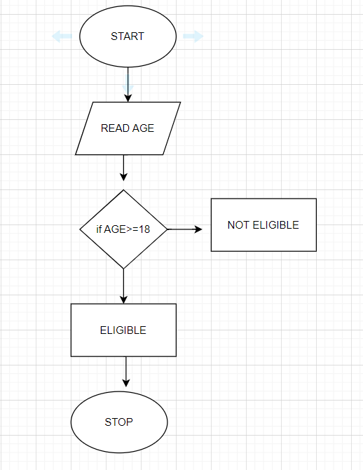

**ADMISSION POSSIBILITY**

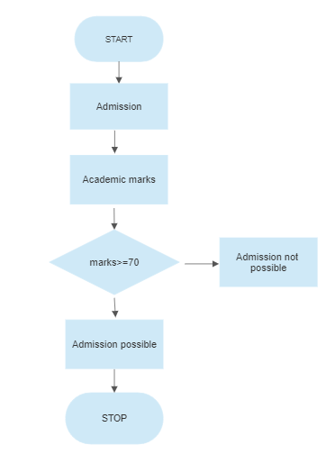

**SUM AND AVERAGE FLOWCHART**

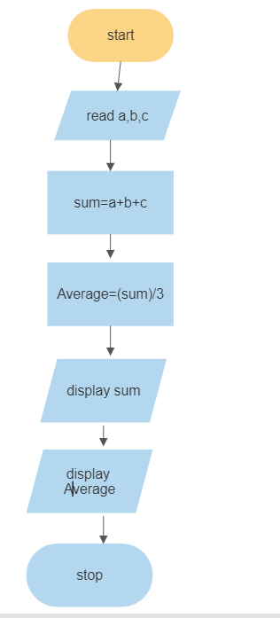+

**FACEBOOK LOGIN**

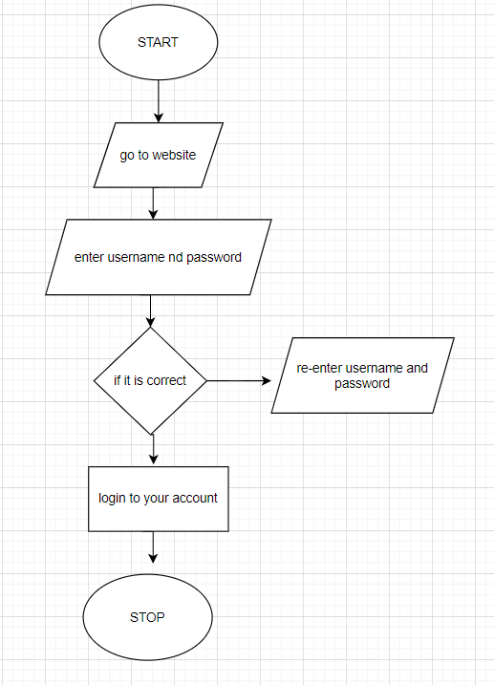

**PURCHASING A MOBILE**

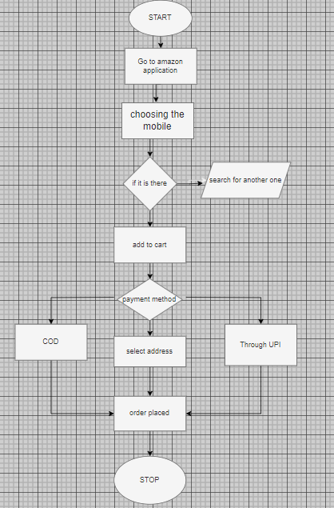

**WINNING CHANCES OF TEAM**

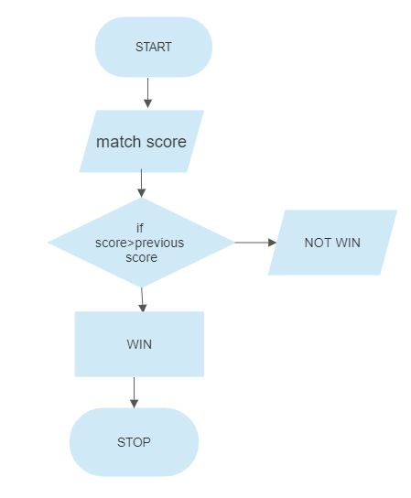

**PRINT BITLABS 10 TIMES**

